Yarram Secondary College  
86 James Street Yarram 3971  
PO Box 135 Yarram 3971  
Telephone: 5182 5522  
Facsimile: 5182 6114  
Email: [yarram.sc@edumail.vic.gov.au](mailto:yarram.sc@edumail.vic.gov.au)  
Website: [www.yarramsc.vic.edu.au](http://www.yarramsc.vic.edu.au)

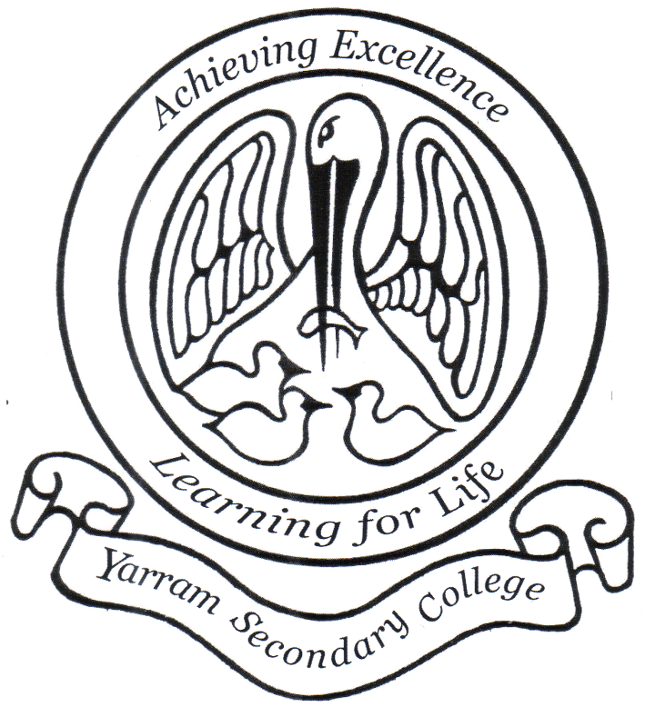

Yarram Secondary College  
**Sun Smart Policy**

**2022**

Date ratified by Staff: October 2022  
 Date ratified by School Council:

Review date: 16/10/2026

**SUNSMART POLICY**

**Help for non-English speakers**

If you need help to understand the information in this policy, please contact Yarram Secondary College front office on 5182 55 22.

**Purpose**

The purpose of this policy is to encourage behaviours at Yarram Secondary College to minimise the risk of skin and eye damage and skin cancer.

This policy provides guidelines to:

* support staff and students to use a combination of sun protection measures when UV index levels are 3 or above (generally mid-August – end of April)
* ensure that there are outdoor environments that provide adequate shade for students and staff
* ensure students are encouraged and supported to develop independent sun protection skills to help them to be responsible for their own protection
* support our school’s strategies to meet its duty of care and occupational health and safety obligations to minimise harmful UV exposure and associated harm for students and staff.

**Scope**

This policy applies to all school activities, including camps and excursions. It is applicable to all students and staff.

**Policy**

Excessive exposure to the sun’s ultraviolet (UV) radiation can cause health problems including sunburn, damage to skin and eyes, and an increased risk of skin cancer.

UV radiation:

* cannot be seen or felt
* can be reflected off surfaces such as buildings, asphalt, concrete, water, sand and snow
* can pass through light clouds
* varies in intensity across the year (highest in Victoria from mid-August – end of April)
* peaks during school hours.

Sun safety is a shared responsibility and staff, parents and students are encouraged to implement a combination of sun protection measures whenever UV levels reach 3 and above (typically from mid-August to the end of April in Victoria). Information about the daily local sun protection times is available via [sunsmart.com.au](http://www.sunsmart.com.au) or bom.gov.au.

Yarram Secondary Collegehasthe following measures in place to help reduce the risk of excessive UV sun exposure for staff and students.

**Shade**

Yarram Secondary Collegewill provide sufficient options for shelter and trees to provide shade on school grounds, particularly in places such as:

* where students congregate for lunch
* the canteen
* popular play areas
* assembly areas
* sporting grounds

When building works or grounds maintenance is conducted at Yarram Secondary College that may impact on the level of shading available to staff and students, a review of the shaded areas available will be conducted and further shading installed as appropriate.

**Sun protective uniform/clothing**

Yarram Secondary College’s school uniform and dress code includes sun-protective clothing, including:

* loose, cool, closely woven fabric
* shirts with a collar and/or high necklines
* tops with elbow length or long sleeves
* longer style shorts and skirts

As we are a secondary school, we expect students to take responsibility for being SunSmart by wearing a school hat during outdoor activities or staying in the shade, if they are not wearing sunscreen.

Staff and students are encouraged to wear hat styles that protect the face, neck and ears when outdoors, for example the schools bucket hat.

Students who are not wearing appropriate protective clothing or a hat may be asked to play in the shade or in a suitable area protected from the sun.

**Sunscreen**

Yarram Secondary College encourages all staff and students to apply SPF30 (or higher) broad-spectrum, water-resistant sunscreen daily whenever UV levels reach 3 and above. Sunscreen should be applied at least 20 minutes before going outdoors and reapplied every two hours according to [manufacturer’s instructions](https://www.tga.gov.au/book/4-labelling-and-advertising).

At Yarram Secondary Collegestudents are welcome to attend the office to access sunscreen. Staff and students who may suffer from allergic reactions from certain types of sunscreens are encouraged to contact the front office to implement a management plan to reduce the risk of an allergic reaction at school.

Staff and families should role model SunSmart behaviour and are encouraged to apply SPF 30 (or higher) broad-spectrum, water-resistant sunscreen when outside.

**Sunglasses**

Where practical Yarram secondary College encourages students and staff engaged in outdoor activities to wear close-fitting, wrap-around sunglasses that meet the Australian Standard 1067 (Sunglasses: Category 2, 3 or 4) and cover as much of the eye area as possible.

**Curriculum**

Students at our school are encouraged to make healthy choices and are supported to understand the benefits and risks of sun exposure. Yarram Secondary College will address sun and UV safety education as part of SOSE and the school nurse

Staff are encouraged to access resources, tools, and professional learning to enhance their knowledge and capacity to promote sun smart behaviour across the school community.

SunSmart behaviour is regularly reinforced and promoted to the whole school community through newsletters, school website/intranet, staff and parent meetings, school assemblies, student and teacher activities and at student enrolment/new staff orientation.

**COMMUNICATION**

This policy will be communicated to our school community in the following ways:

* Available publicly on our school’s website
* Included in staff induction processes
* Included in staff handbook/manual
* Discussed at parent information nights/sessions
* Reminders in our school newsletter
* Discussed in student forums
* Hard copy available from school administration upon request

**Further Information and Resources**

* the Department’s Policy and Advisory Library:
  + [Sun and UV Protection Policy](https://www2.education.vic.gov.au/pal/sun-protection/policy)
  + [Duty of care](https://www2.education.vic.gov.au/pal/duty-of-care/policy)
* [SunSmart](http://www.sunsmart.com.au/)
* [Achievement Program](http://www.achievementprogram.health.vic.gov.au/schools)’s SunSmart policy

**POLICY REVIEW AND APPROVAL**

|  |  |
| --- | --- |
| Policy last reviewed | October 2022 |
| Approved by | School Council |
| Next scheduled review date | October 2026 |