Yarram Secondary College
86 James Street Yarram 3971
PO Box 135 Yarram 3971
Telephone: 5182 5522
Facsimile: 5182 6114
Email: yarram.sc@edumail.vic.gov.au
Website: www.yarramsc.vic.edu.au

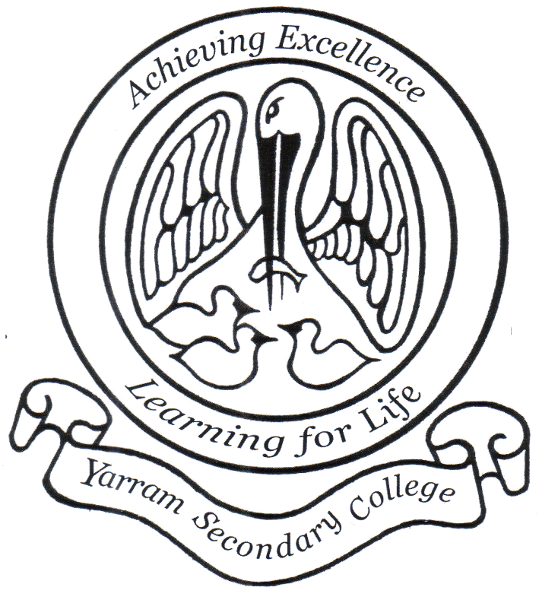
Yarram Secondary College
Child Safety Induction Pack - Volunteers
2022

Date ratified by Staff: 6/6/2022
Date ratified by School Council: N/A
Review date: 6/6/2024

Yarram Secondary College Child Safety Induction Pack - Volunteers
Instructions: Under the Child Safe Standards, schools must ensure all volunteers working at the school or a school activity where children are likely to be present are aware of the school’s Child Safety and Wellbeing Policy and Child Safety Code of Conduct. We also recommend volunteers are made aware of the school’s Child Safety Responding and Reporting Obligations Policy and Procedures. Under the Child Safe Standards volunteers must also be ‘attuned to signs of harm’ which is why we have also included a link to the PROTECT website: Identify Child Abuse.

Purpose
Thank you for your interest in volunteering at our school. The purpose of this induction pack is to ensure Yarram Secondary College volunteers are familiar with our policies and procedures relating to child safety and understand the important role they play in maintaining and promoting the safety of our students.
Volunteers must read the suite of policies and procedures in the links below before commencing any work where children are likely to be present.

Key messages
- Yarram Secondary College is committed to the safety and wellbeing of all children. We want children attending our school to be safe, happy, and respected.
- We are committed to creating inclusive environment where diversity is supported, and students feel safe to bring their whole selves to school.
- Allegations and concerns relating to the safety and wellbeing of our school community will be treated very seriously and consistently with our policies and procedures.
- We are committed to preventing child abuse, identifying risks early and removing and reducing these risks.
- Everyone has a role to ensure children are safe – if something does not feel right, speak up. If you have any concerns about any inappropriate behaviours in the school community, you should speak to the Principal or Assistant Principal. If this would not be appropriate in the circumstances, you can contact the Southeast Regional Office of the Department of Education and Training on 1300 338 691.

Induction materials – must read
This induction pack contains the following documents that all new volunteers must read and familiarise themselves with. Please click on the hyperlinks to access each document. If you would prefer a hard copy of this pack, please contact the team in the office who will happily provide you with one.
- Yarram Secondary College Volunteers Policy
- Yarram Secondary College Child Safety and Wellbeing Policy
- Yarram Secondary College Child Safety Responding and Reporting Obligations Policy and Procedures
- Yarram Secondary College Child Safety Code of Conduct
- PROTECT: Four Critical Actions for Schools – Responding to incidents, disclosures, and suspicions of child abuse
- PROTECT: Identify child abuse

Contact
We value your feedback on ways we can continue to improve and strengthen our child safety approach and encourage you to contact principal or assistant principal with any comments or questions.

